Volunteer with CHO ! 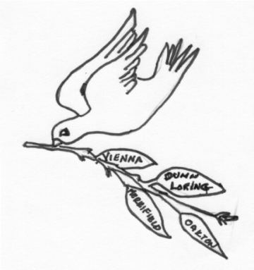
CHO has several volunteer opportunities for individuals who are interested in making a difference by assisting with tasks that are essential to the community services that we provide. Most activities can be done at your convenience, although there are certain time periods when the work is more concentrated.
If you would like to learn more, please contact our Volunteer Coordinator, Erinn Connor at volunteer@cho-va.com, or call CHO at 703-281-7614 and leave a message in box # 2.
Arabic & Spanish Translators: We occasionally need Arabic or Spanish language skills to assist our Emergency Services and other CHO teams.
Community Services Volunteers: Individuals are needed in to assist in the CHO Food Closet, Clothes Closet, Furniture Closet and Christmas Store. Time commitments are flexible, depending on your interest in volunteering on a regular basis or for specific events throughout the year. Please consider sharing some time with us. All help is welcome and very much needed!
Donor Liaison: Assist the CHO secretary with donor correspondence—for example, thank you letters, general inquiries and tax information -- and update mailing list. You can do the work at a time you choose as long as it is completed within a reasonable time. No special training is required, but access to a good quality printer and attention to detail is needed. Estimated time commitment, 20-35 hours a year.
Publicity Assistant (s): Assist Publicity Chair in any one or more of the following: (1) preparation of the bi-annual (May and November) 4-6 page newsletter (write articles, take photos, arrange copy (we currently use Microsoft Word) and arrange for printing and mailing with outside printer (time commitment of 10-25 hours per year); (2) publicize and promote various CHO fundraisers and events, including writing copy and sending to local papers and CHO representatives (time commitment 15-30 hours per year); and (3) maintain and update CHO publicity materials (cards, brochures) and make extra copies or changes as needed; distribute information to CHO members and maintain website (time commitment of 15-20 hours a year); attend and follow up on monthly board meetings. You do not need to agree to perform all of these tasks; you can choose one or part of one. Please consider sharing your computer and writing skills to help us raise awareness of events and the needs of those we serve.

